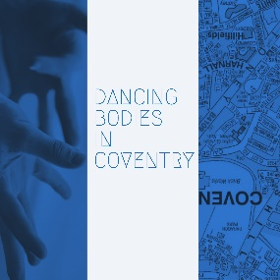
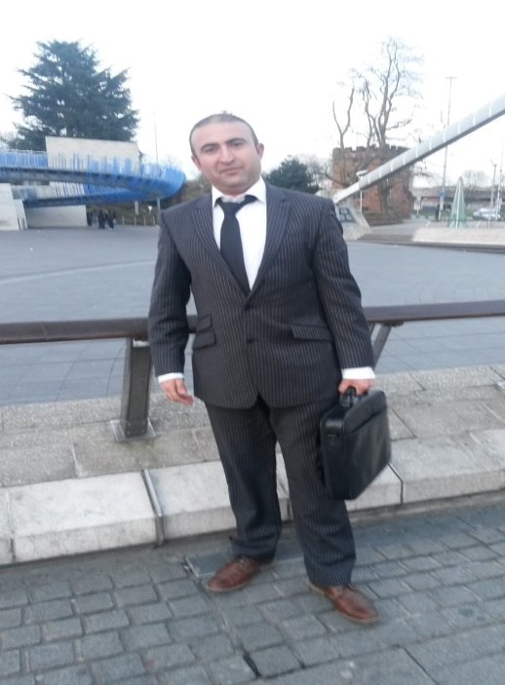
- What is your name?
My name is Sroosh Kouhyar.
- What is your job?
I am working as a manager of Integration project and housing project at Coventry Refugee and Migrant Centre (CRMC)
- Where you were born?
I was born in northern province of Badakhshan in Afghanistan.
- What does Coventry mean to you?
Coventry means home to me, which offered me shelter and sanctuary, enabled me to integrate and resettle, improve and progress as a person.
- What is your experience of living and working in Coventry?
I am really pleased that I have the privilege of living and working here in Coventry; the city of sanctuary, peace and reconciliation.
- Can you share a picture of a place in Coventry that means something to you?
I would like to share the Picture of Coventry City Centre, as I am a proud Coventrian and enjoy living and working here in Coventry.

