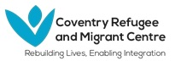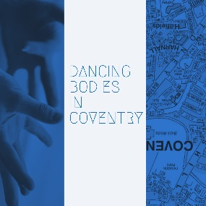
- What is your name?
My name is Rachel Harrington.
- What is your job?
I am working as an Employment Officer at Coventry Refugee and Migrant Centre (CRMC)
- Where you were born?
I was born near a town called Bracknell which is near Reading. I moved to Bedworth which is just north of Coventry when I was 11 with my family but went to school in Coventry so spent a lot of time here in Coventry.
- What does Coventry mean to you?
The history of Coventry and the fact so many things were made here, such as watches, clocks, cars, parts for my airplanes (I believe). So to me it is a city of production and industry. I also see it as a city which survived the war so has bounced back and has a lot of resilience and is not afraid to try new things or to take risks. I feel like the damage caused by the war created a welcoming environment here. Coventry is a city that welcomes everyone from immigrants from India and Pakistan in the 1960s and 1970s to Syrian families and EU migrants today and students from all over the world. It is a very diverse city and that is one of its strengths
- What is your experience of living and working in Coventry?
I think the landscape is always changing. I feel like the city centre has changed so much in 20 years. I am happy that the council is doing work to add more green spaces to the city centre. I feel there is so much going on here and so many different communities who all live peacefully together and work and interact together.
- Can you share a picture of a place in Coventry that means something to you?
I choose this place because I worked for Coventry City Council as a Project Assistant for a year and a half. was a job I enjoyed so I have happy memories of working there.
