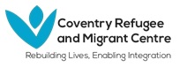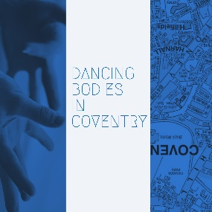
- What is your name?
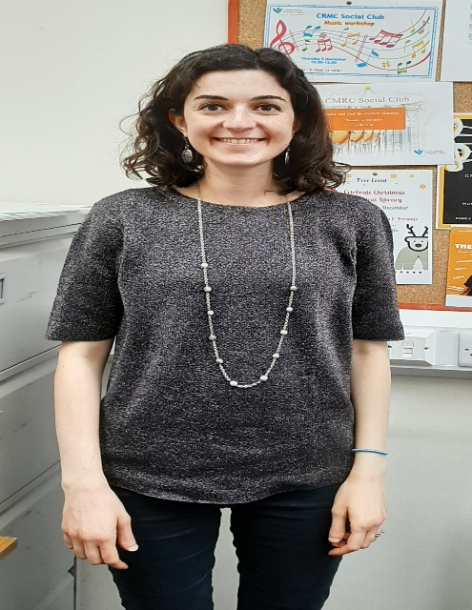
My name is Mary Unsworth.
- What is your job?
I am working as a Team Leader of Integration project at Coventry Refugee and Migrant Centre (CRMC)
- Where you were born?
I was born in Beirut, Lebanon.
- What does Coventry mean to you?
Coventry to me is my own space. I live in Birmingham but work in Coventry. My husband’s family and most of my friends live and work in Birmingham too. Coventry is my own space apart from them. I take trains to get there and back. I can do my own thing on the way, daydream or click away on my phone without much interruption. I also love how diverse it is. Being a foreigner myself, I love meeting people from around the world in Coventry, experience a glimpse of their culture, learn a few words of their language and try out their food.
- What is your experience of working in Coventry?
I’ve been working in Coventry for the past 4 years now with asylum seekers, refugees and migrants. I have found it welcoming, diverse and has many opportunities. It’s been lovely to make connections in the city, especially ones that benefit our clients. It’s also so rich in history – one that hasn’t always been peaceful which is something our families can relate to. I’ve also found it accessible, in terms of commuting from another city to work there and it’s pretty connected to other large cities and towns around it.
- Can you share a picture of a place in Coventry that means something to you?
I’ve chosen a picture of CRMC, my workplace. It has given me an opportunity to work with individuals from all over the world, both staff and client group. I’ve always found it a small escape from the predominant culture in the country.
